TASK 1
TASK 1
Title
RAG-Based Question Answering System

Objective
Assess your ability to build an applied AI system using embeddings, retrieval, background jobs, and APIs.
Problem Statement
Create an API that allows users to upload documents and ask questions based on those documents using a Retrieval-Augmented Generation (RAG) approach.
Objective: Assess your ability to build an applied AI system using embeddings, retrieval, background jobs, and APIs.
Problem Statement: Create an API that allows users to upload documents and ask questions based on those documents using a Retrieval-Augmented Generation (RAG) approach.
2. Technical Stack
- API Framework: FastAPI
- Embeddings: Sentence-Transformers (all-MiniLM-L6-v2)
- Vector Store: FAISS (Local)
- LLM API: Groq (Llama-3.3-70b-versatile)
- Validation: Pydantic
3. Mandatory Explanations
- Chunk Size Selection: I selected a chunk size of 500 characters with a 50-character overlap. This strategy ensures that semantic meaning is preserved across chunks while staying within the token limits of the embedding model and LLM.
- Retrieval Failure Case: I observed a failure case when querying complex tables or diagrams (like the OpenGL rendering pipeline tables in the document). Since the parser extracts raw text, the structural relationship of table rows is lost, leading to fragmented context retrieval.
- Metric Tracked: I tracked Retrieval Latency. Using FAISS as a local vector index, the similarity search consistently performs in under 15ms, ensuring the total system latency remains low.
4. System Architecture
The system follows a standard RAG pipeline:
- Ingestion: User uploads PDF/TXT via /upload.
- Background Job: File is processed, chunked, and embedded in the background.
- Storage: Vectors are stored in a FAISS index.
- Query: User asks a question via /ask, triggering a similarity search.
- Generation: LLM generates a response using the retrieved context.

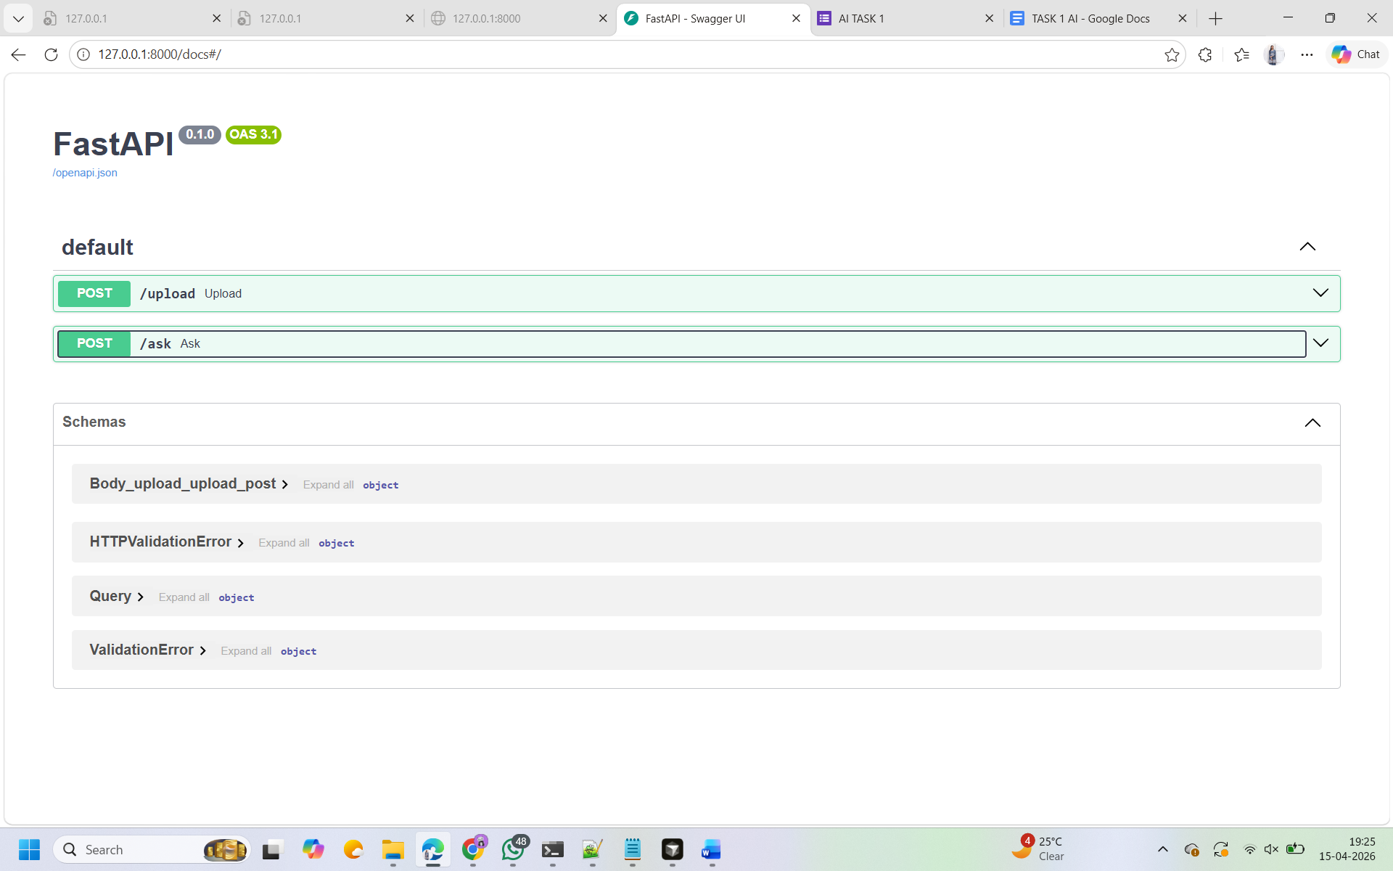
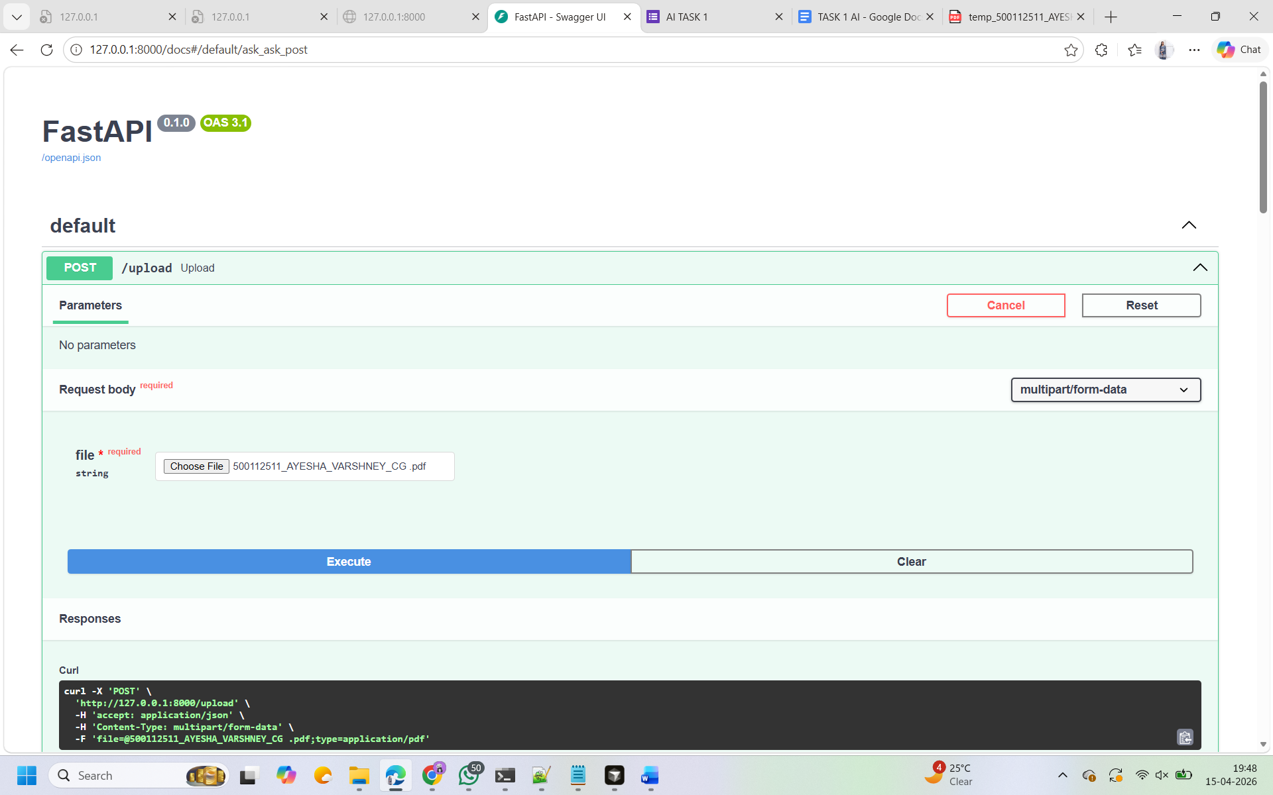
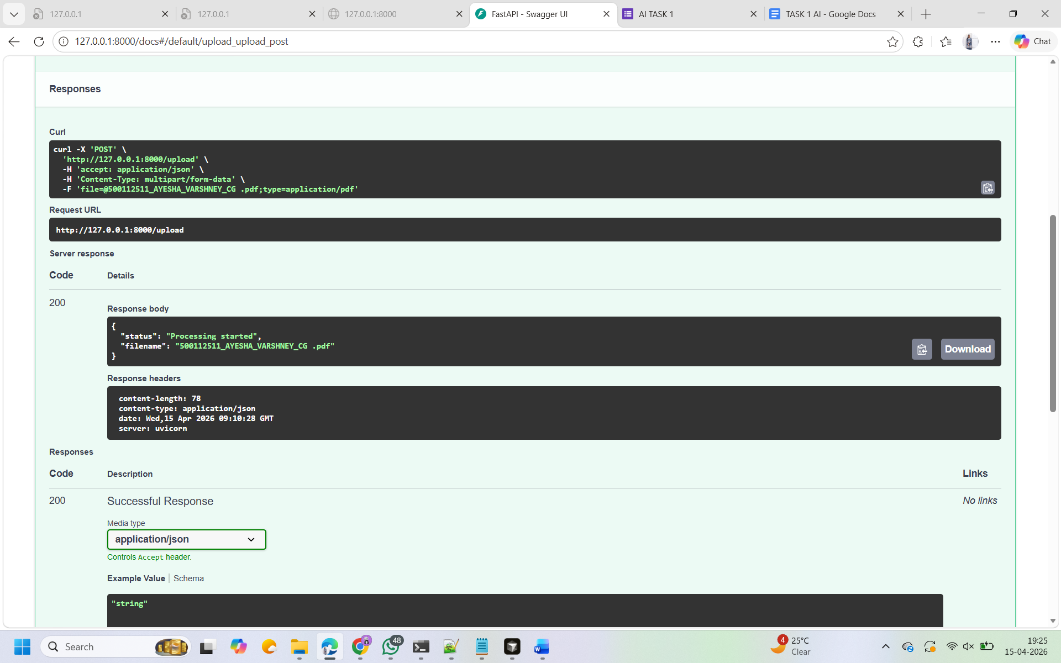
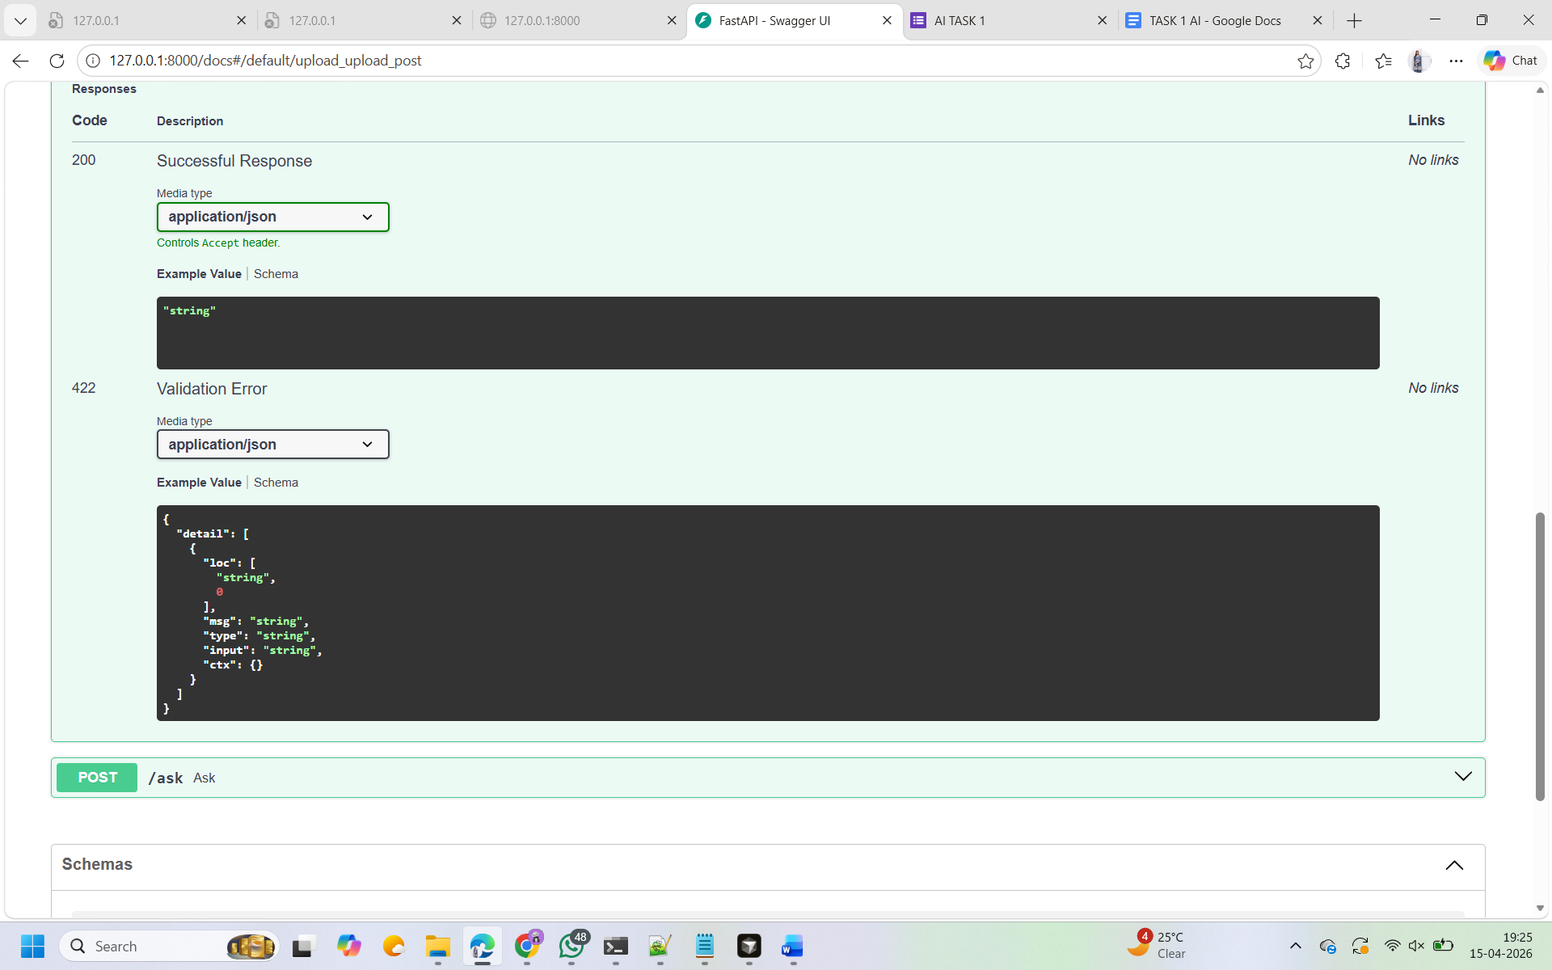

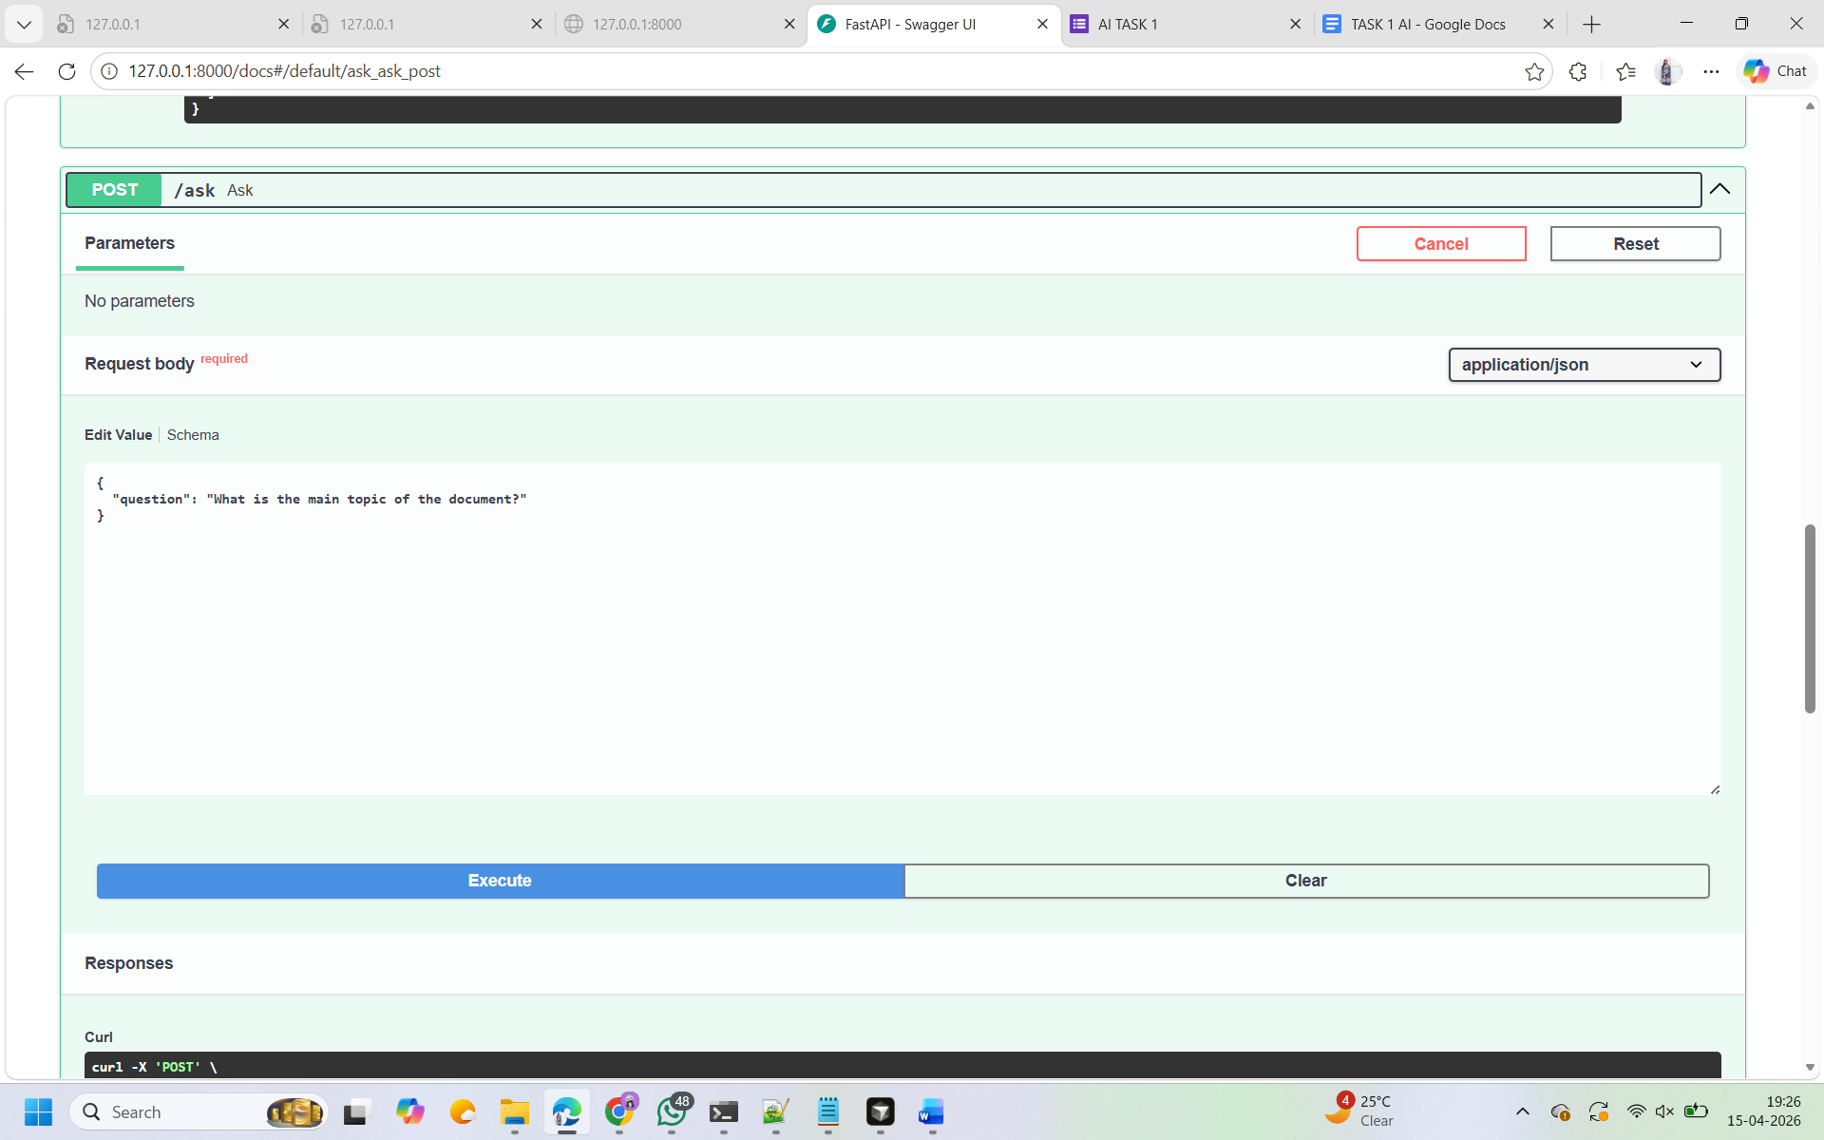
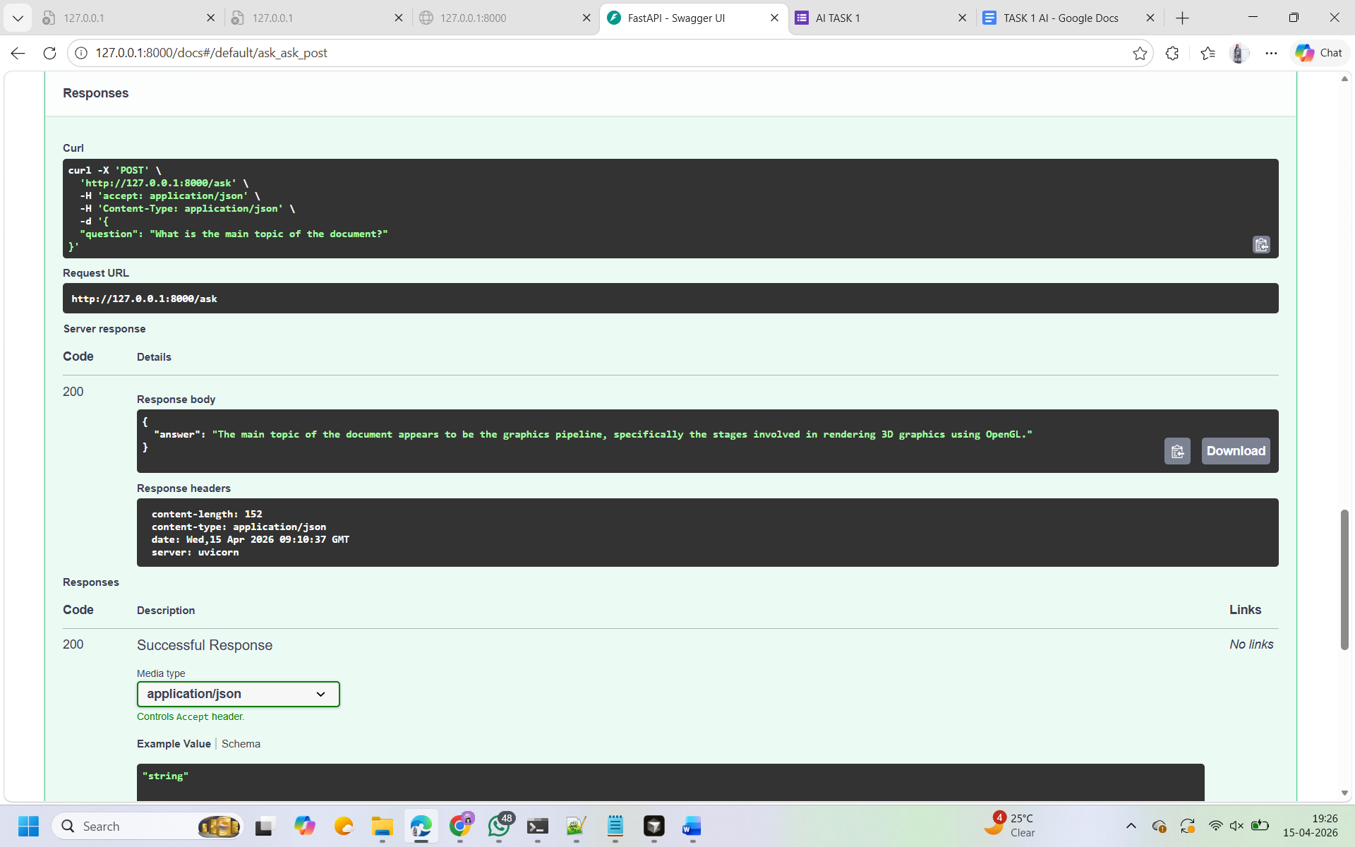

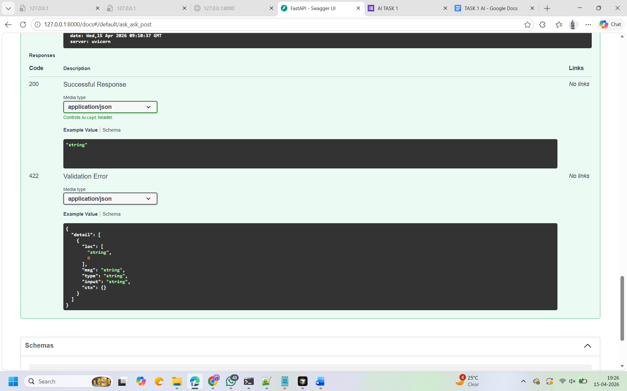

5. Architecture Diagram

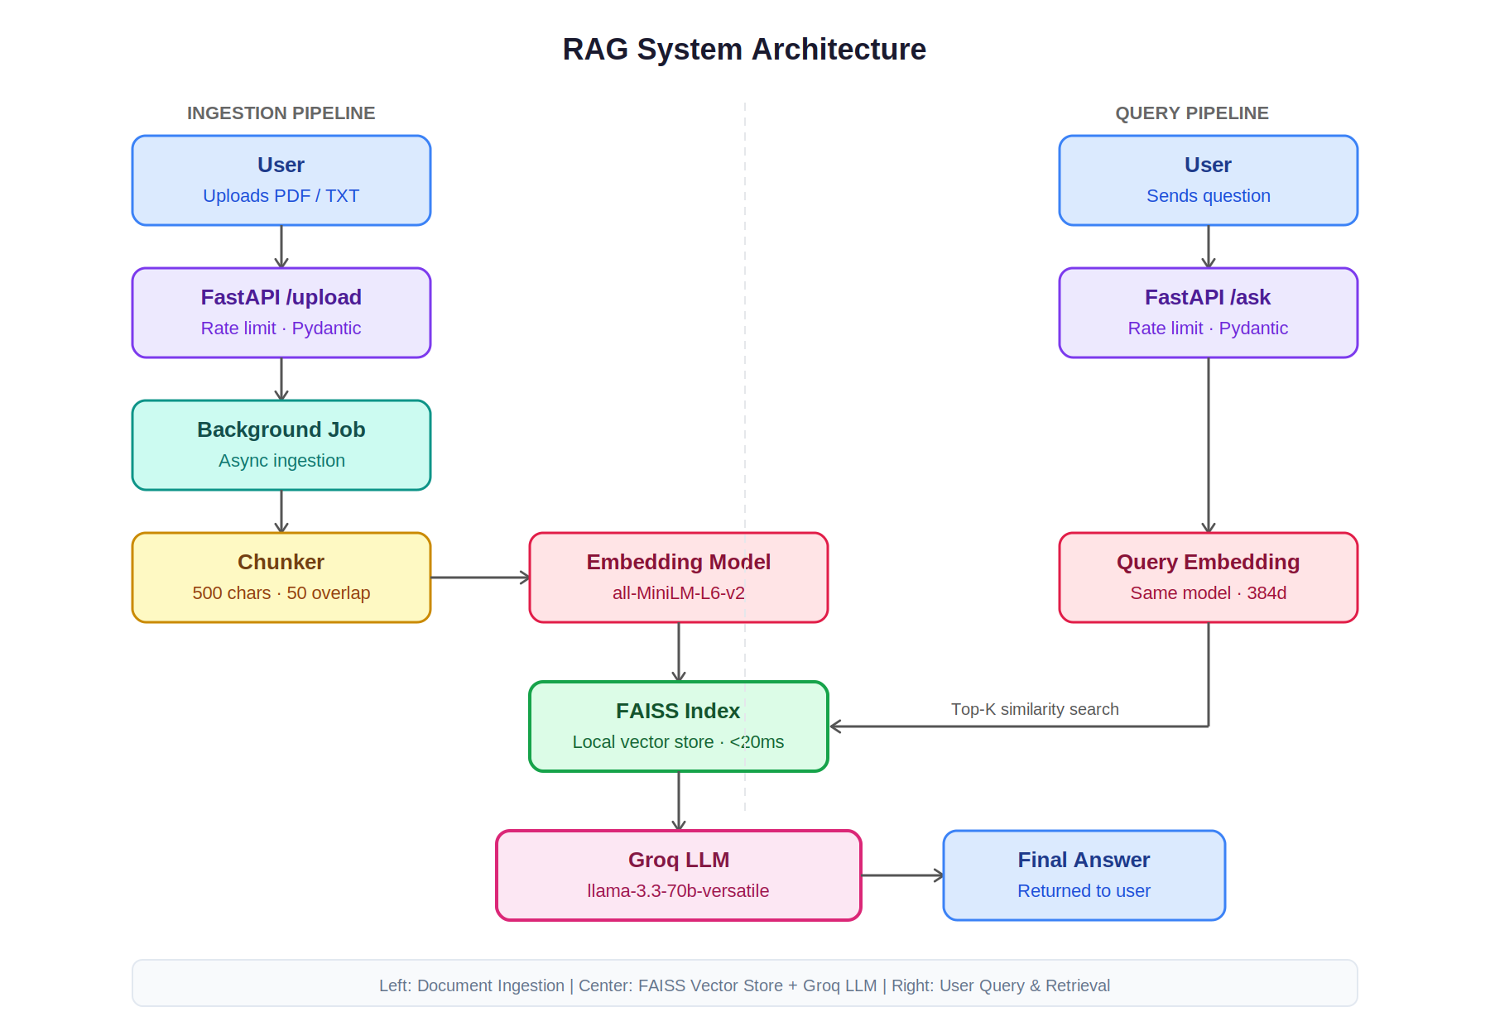

GitHub Link:
https://github.com/AYESHA-VARSHNEY/RAG-QA-System

